**Lab for Chapter 1:**

**Introduction to Advanced Analytics & Data Science**

Contents

1 Exercise 0: Log on to Azure ML Studio & create a new experiment **.....................................................3**

2 Exercise 1: Upload a dataset to the workspace from a local file**............................................................4**

3 Exercise 2: Reading a data source through http **...................................................................................5**

4 Exercise 3: Reading a dataset from Azure Blob Storage **.......................................................................7**

5 Exercise 4: Writing Datasets to an Azure Blob Storage **........................................................................ 9**

6 Exercise 5: Connecting to Azure Blob Storage **.................................................................................... 10**

1 **Exercise 0: Log on to Azure ML Studio & create a new Experiment**

1. Access Azure ML

a. Visit <https://studio.azureml.net/>

b. Log on using your credentials. If you have not signed up already, do it now.

2. Create a new experiment

a. Click on: **New 🡪 Experiment 🡪 Blank Experiment**

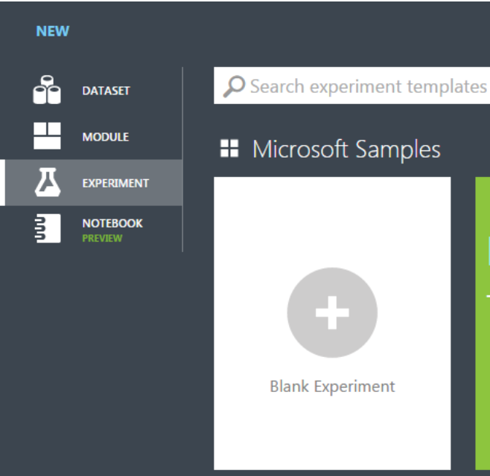

b. Name your experiment at the top ‘Lab 01 - Introduction to Advanced Analytics & Data Science’

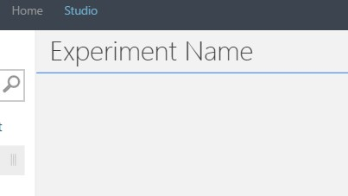

**2 Exercise 1: Upload dataset to the workspace from a local file**

1. For this exercise, we will use the dataset file “***iris.data.CSV***” or alternatively you can create the same

by following steps 2 & 3.

2. Visit: <http://archive.ics.uci.edu/ml/machine-learning-databases/iris/iris.data>

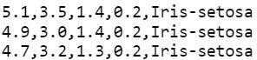

1. Notice how its comma delimited. That lets you know that it can be read as a CSV.
2. Excel Files and delimited text files can be read as CSV.
3. Notice that this data does not have headers. It will ask you for this information later.

3. Download and save the file as a CSV file. ‘***iris.data.CSV’***

4. Import the dataset into Azure ML Studio.

a. Click on: **New 🡪 DATASET 🡪 FROM LOCAL FILE**

b. Import as a new dataset.

5. Go into any experiment and verify that the dataset has been imported.

a. The data will be under a directory called “Saved Datasets” within any experiment.

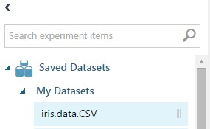

b. Please note that by default Azure ML ships with a dataset called “Iris Two Class Data,”

do not confuse that with the data you just imported.

**3 Exercise 2: Reading a data source through http**

1. In the newly created Lab 01 experiment, Drag and drop an ‘Import Data’ module from the menu on left.

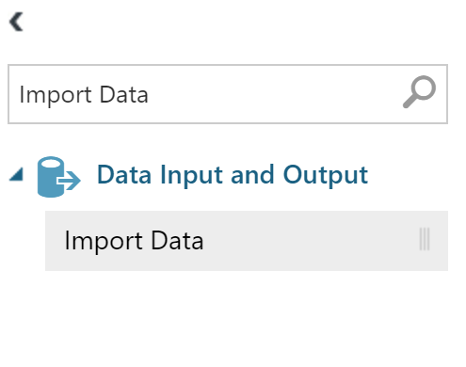

2. Specify ‘Web URL via HTTP’ as the Data source.

3. In the URL field, enter [http://archive.ics.uci.edu/ml/machine-learning-databases/iris/iris.data](http://archive.ics.uci.edu/ml/machine-learning-databases/iris/iris.dat)

4. Choose CSV from the ‘Data Format’ drop down

5. Leave the ‘CSV or TSV has header row’ option unchecked

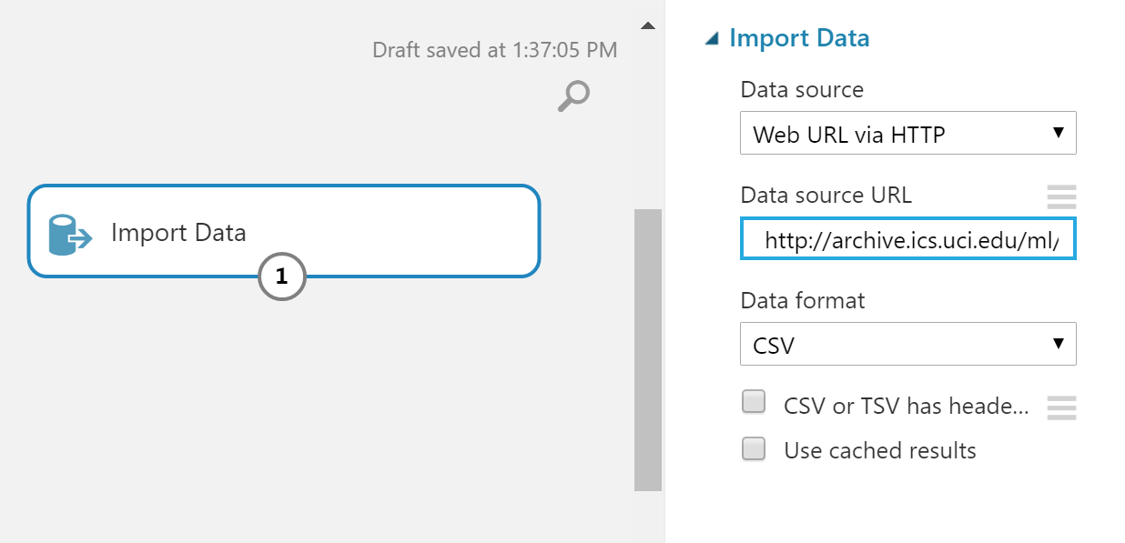

6. Save your experiment with “SAVE AS” on the menus at bottom.



7. Run the experiment to execute the import and parse.

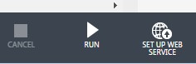

8. Preview the data by visualizing the output of the ‘Import Data’ module. Right click the bottom middle

node of the ‘Import Data’ module to access the menu and click “Visualize”.

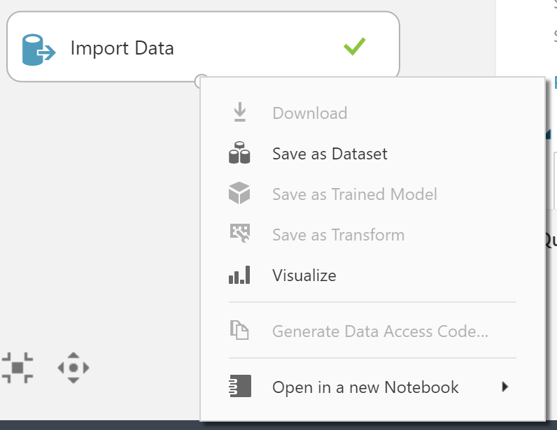

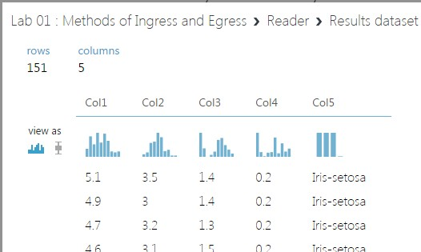

**4 Exercise 3: Reading a dataset from Azure Blob Storage**

1. Drag and drop Import Data module from the menu on left.



2. Input the sample blob storage account we have set up for you.

* + 1. **Data Source**: Azure Blob Storage
    2. **Authentication type**: Storage Account
    3. **Account name**: analyticsbootcamposlo
    4. **Account key:**

WxHhL/+EhKva80Y3x25Id4gYndW0H6hzo1ChikRzaD21rtf3Dy2JIy4mNcSWw7ohqqDA1UPB29OTfoG7ogP2+w==

* + 1. **Path to container, directory or blob:** advancedanalytics/iris.csv
    2. **Blob file format**: CSV
    3. **File has header row:** Checked

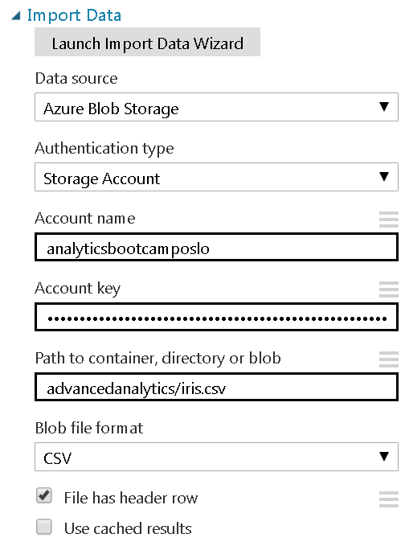

3. Run the experiment to execute the import and parse



4. Preview the data by visualizing the output of the ‘Import Data’ module. Right click the bottom middle node of the ‘Import Data’ module to access the menu.

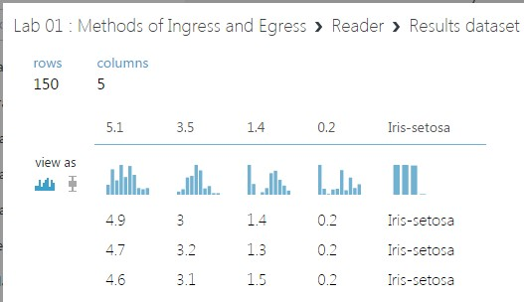

**5 Exercise 4: Writing Datasets to an Azure Blob Storage**

1. Drag any dataset into your workspace.

2. Drag ‘Export Data’ module in and connect the dataset to the writer.

3. Input the sample blob storage account we have set up for you.

**Please specify data destination:** Azure Blob Storage

**Please specify authentication type:** Account

**Azure account name:** analyticsbootcamposlo

**Azure Account key:**

WxHhL/+EhKva80Y3x25Id4gYndW0H6hzo1ChikRzaD21rtf3Dy2JIy4mNcSWw7ohqqDA1UPB29OTfoG7ogP2+w==

**Path to blob beginning with container**: advancedanalytics/iris-write_<YourName>.csv

**Azure blob storage write mode**: Overwrite

i. Write mode of “Error” will return an error if the filename already exists on

storage account.

**File format for blob file**: CSV

**Write blob header row:** Checked

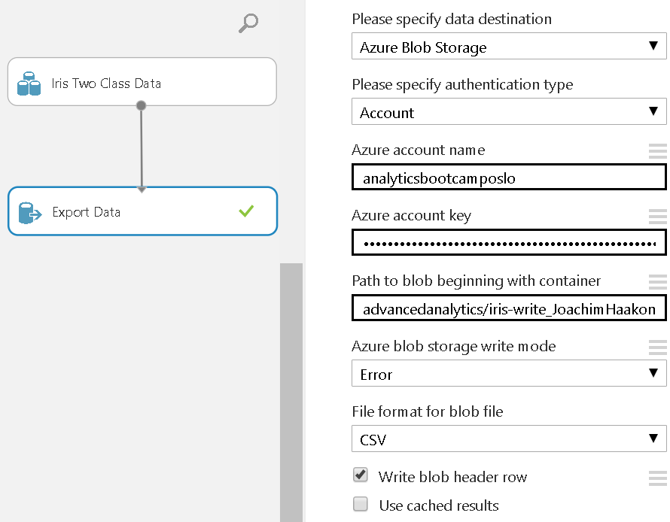

4. Run the experiment to execute dataset writing.



**6 Exercise 5: Connecting to Azure Blob Storage**

1. Download and Install “Azure Storage Explorer” on your machine from:

https://azure.microsoft.com/en-us/features/storage-explorer/

2. Once installed, open “Azure Storage Explorer” and click on “Add Account”

3. Provide below details and click on “Add Storage Account”

a. **Storage account name:** analyticsbootcamposlo

b. **Storage account key:** WxHhL/+EhKva80Y3x25Id4gYndW0H6hzo1ChikRzaD21rtf3Dy2JIy4mNcSWw7ohqqDA1UPB29OTfoG7ogP2+w==

4. Once connected, check that, the name of the file provided in Exercise 4 (iris-

write_<YourName>.csv) is present in the Storage account.

5. You can download the file, by selecting the file and clicking on “Download” button from the “Blob container” ribbon on top.

6. Download and check the contents of the “iris-write_<YourName>.csv”

